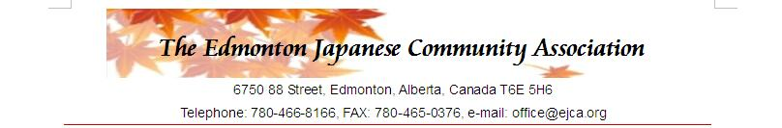
2019-2020

Japan Today School Program - Application Form

Name of School:

Number of Participants: Students ( ); Teachers/Others ( ); Total ( )

Name of Teacher:

Contact Address:
Phone: E-mail:

Please choose A) Japan Today at the EJCA Centre or B) Japan Today at your school.

A. Japan Today at the EJCA Centre….Please submit an application 3 weeks prior to the dates.

Date of your 1st choice: (Please circle: AM or PM)

2nd choice: （Please circle: AM or PM）

B. Japan Today at your school….Please submit an application 6 weeks prior to the dates.

Total number of students: ( ) 3 groups (will be held in the morning), or

( ) 4 - 6 groups (morning to early afternoon)

Date of your 1st choice:
2nd choice:

Sessions: Japanese Language, Karate and two sessions of your choice.

Please circle two: Kimono Slide show Origami

We will contact you to discuss about the schedules and other arrangement.

………………………………………………………………………………………………………………………………….

* The dates available are at: http://ejca.org/images/Japan-Today/JapanTodayCalendar.jpg

Application form and inquiry to: Yukiko Nagakura (Email: ynaga@shaw.ca)

Please note any inquiries or special requests for your school:

